

PRACTICAL FILE

**HINDU INSTITUTE OF MANAGEMENT**

DATABASE MANAGEMENT SYSTEM

BCA 225 B



SUBMITTED TO:-

MRS. SONAM

SUBMITTED BY:-

UMESH

BCA 2nd YEAR

## What is Data?

In simple words data can be facts related to any object in consideration.

For example your name, age, height, weight, etc are some data related to you.

A picture , image , file , pdf etc can also be considered data.

**What is Database?**

Database is a systematic collection of data. Databases support storage and  manipulation of data. Databases make data management easy. Let's discuss few examples.

An online telephone directory would definitely use database to store data pertaining to people, phone numbers, other contact details, etc.

Your electricity service provider is obviously using a database to manage billing , client related issues, to handle fault data, etc.

Let's also consider the facebook. It needs to store, manipulate and present data related to members, their friends, member activities, messages, advertisements and lot more.

We can provide countless number of examples for usage of databases .

**What is Database management system (DBMS)?**

Database Management System (DBMS) is a collection of programs which enables its users to access database, manipulate data, reporting / representation of  data . It also helps to control access to the  database.

Database Management Systems are not a new concept and as such had been first implemented in 1960s.

Charles Bachmen's Integrated Data Store (IDS) is said to be the first DBMS in history.

With time database technologies evolved a lot while usage and expected functionalities of databases have been increased immensely.

**Types of** DBMS:-

Let's see how the DBMS family got evolved with the time. Following diagram shows the evolution of DBMS categories.

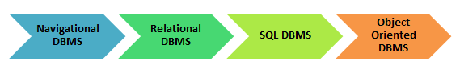

There are 3 major types of DBMS. Let's look into them in detail.

* **Hierarchical** - this type of DBMS employs the "parent-child" relationship of storing data. This type of DBMS is rarely used nowadays. Its structure is like a tree with nodes representing records and branches representing fields. The windows registry used in Windows XP is an example of a hierarchical database. Configuration settings are stored as tree structures with nodes.
* **Network DBMS** - this type of DBMS supports many-to many relations. This usually results in complex database structures.  RDM Server is an example of a database management system that implements the network model.
* **Relational DBMS** - this type of DBMS defines database relationships in form of tables, also known as relations. Unlike network DBMS, RDBMS does not support many to many relationships.Relational DBMS usually have pre-defined data types that they can support. This is the most popular DBMS type in the market. Examples of relational database management systems include MySQL, Oracle, and Microsoft SQL Server database.

**What is MS Access:-**

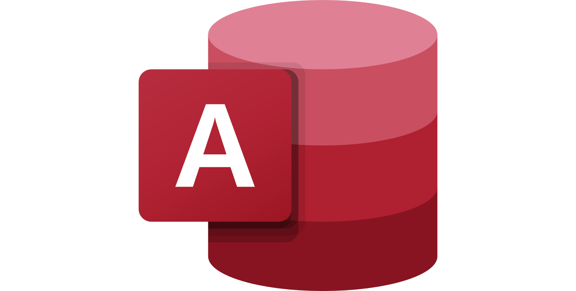

**MS Access Logo**

**Microsoft Access** is a database management system (DBMS) from Microsoft that combines the relational Microsoft Jet Database Engine with a graphical user interface and software-development tools. It is a member of the Microsoft Office suite of applications, included in the Professional and higher editions or sold separately.

Microsoft Access stores data in its own format based on the Access Jet Database Engine. It can also import or link directly to data stored in other applications and databases.

Software developers, data architects and power users can use Microsoft Access to develop application software. Like other Microsoft Office applications, Access is supported by Visual Basic for Applications (VBA), an object-based programming language that can reference a variety of objects including the legacy DAO (Data Access Objects), ActiveX Data Objects, and many other ActiveX components. Visual objects used in forms and reports expose their methods and properties in the VBA programming environment, and VBA code modules may declare and call Windows operating system operations.

In addition to using its own database storage file, Microsoft Access also may be used as the 'front-end' of a program while other products act as the 'back-end' tables, such as Microsoft SQL Server and non-Microsoft products such as Oracle and Sybase. Multiple backend sources can be used by a Microsoft Access Jet Database (ACCDB and MDB formats). Similarly, some applications such as Visual Basic, ASP.NET, or Visual Studio .NET will use the Microsoft Access database format for its tables and queries. Microsoft Access may also be part of a more complex solution, where it may be integrated with other technologies such as Microsoft Excel, Microsoft Outlook, Microsoft Word, Microsoft PowerPoint and ActiveX controls.

* **Advantages of MS ACCESS :-**

Here, are the pros/benefits for using MS Access application:

* Access offers a fully functional, relational database management system in minutes.
* Easy to import data from multiple sources into Access
* You can easily customize Access according to personal and company needs
* Access works well with many of the development languages that work on Windows OS
* It is robust and flexible, and it can perform any challenging office or industrial database tasks.
* MS-Access allows you to link to data in its existing location and use it for viewing, updating, querying, and reporting.
* Allows you to create tables, queries, forms, and reports, and connect with the help of Macros
* Macros in Access is a simple programming construct with which you can use to add functionality to your database.
* It can perform heterogeneous joins between various data sets stored across different platforms
* **Disadvantages of MS-ACCESS :-**

Here, are the cons for using MS Access

* Microsoft Access is useful for small-to-medium business sectors. However, it is not useful for large-sized organizations
* Lacks robustness compared to DBMS systems like MS SQL Server or Oracle
* All the information from your database is saved into one file. This can slow down reports, queries, and forms
* Technical limit is 255 concurrent users. However, the real-world limit is only 10 to 80 (depending on the type of application which you are using)
* It requires a lot more learning and training compares with other Microsoft programs

**Creation of database :**

Select a blank Database to create a new database

Provide a name to database and click create

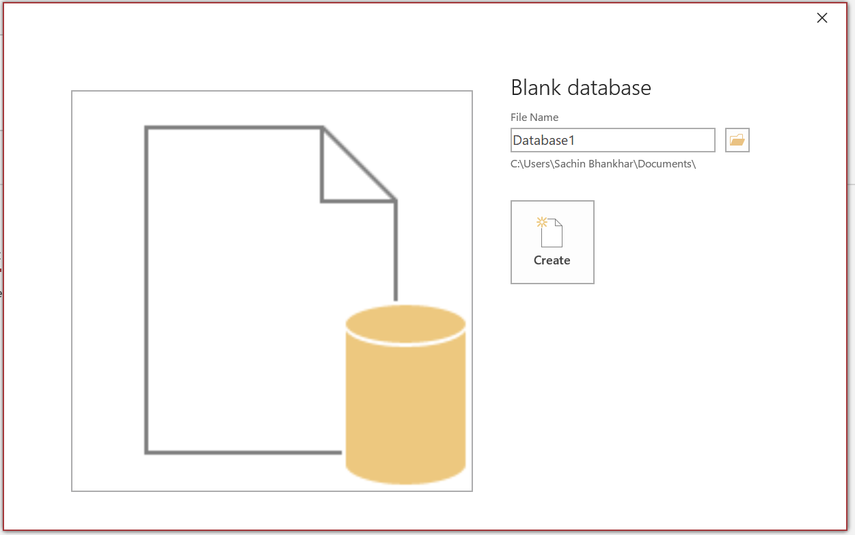

**Structure of a database:**

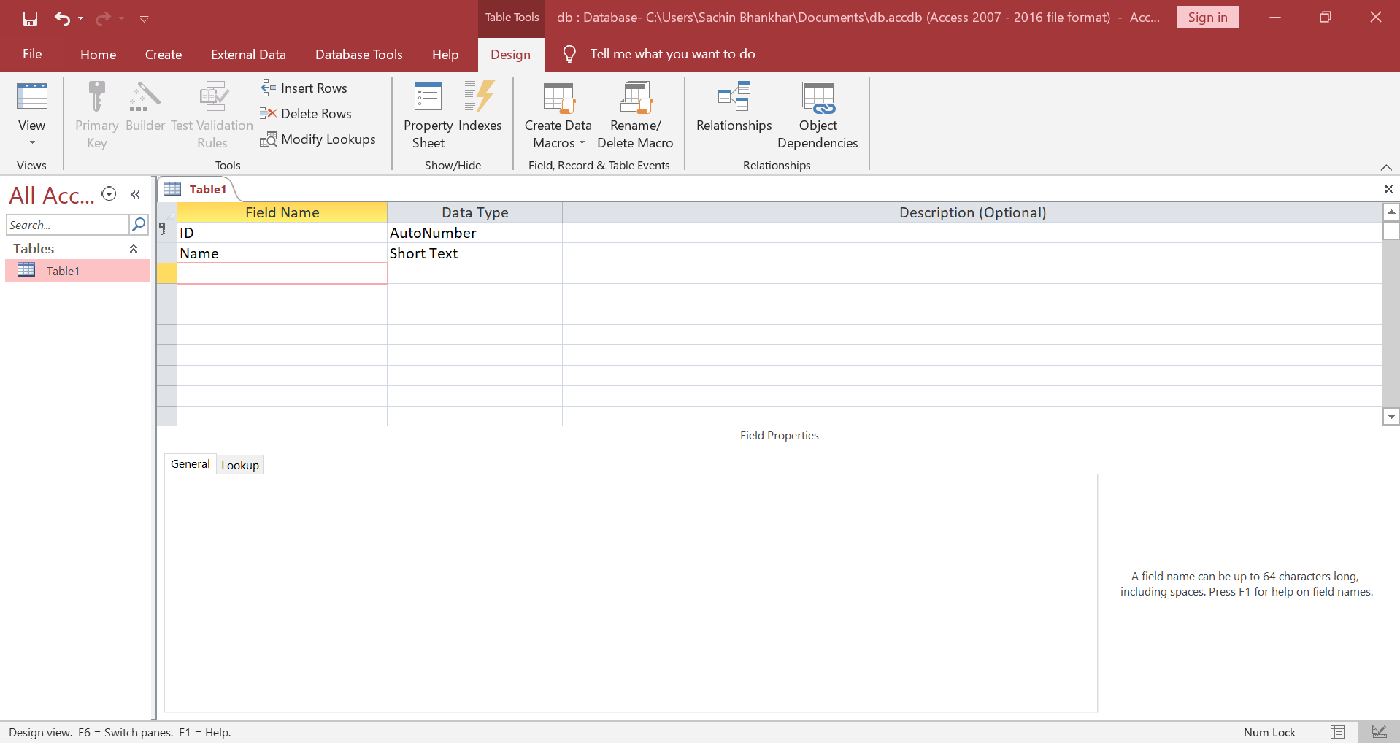

**Designing a table according to student :**

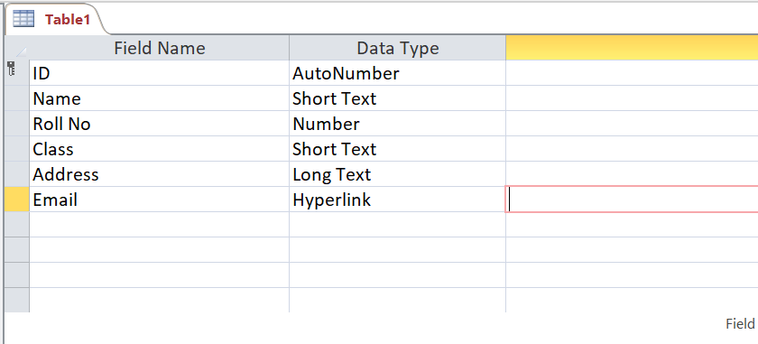

**Data Sheet View of a table to enter entries:**

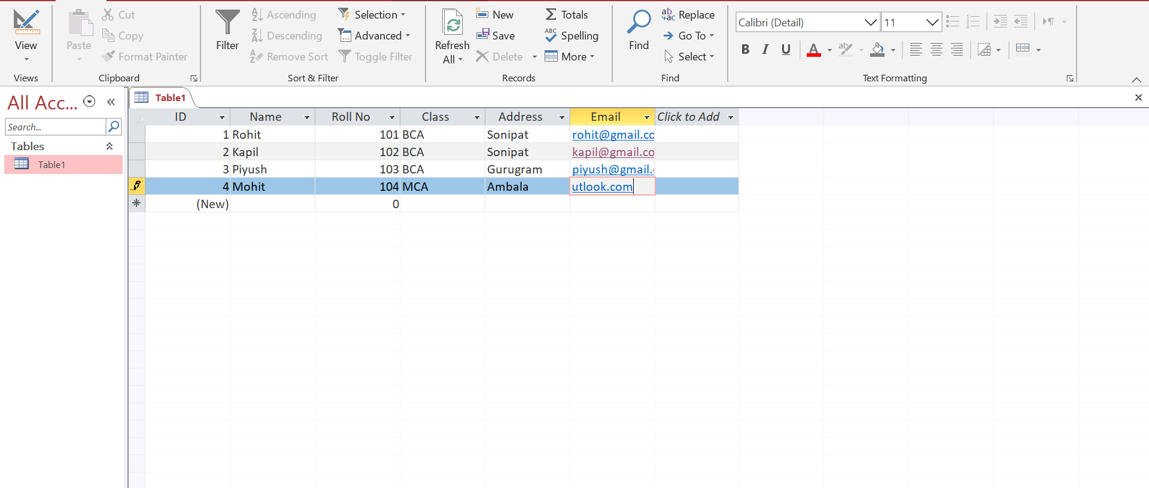

**Form Creation :**

Select form from create menu and the form will automatically be created.

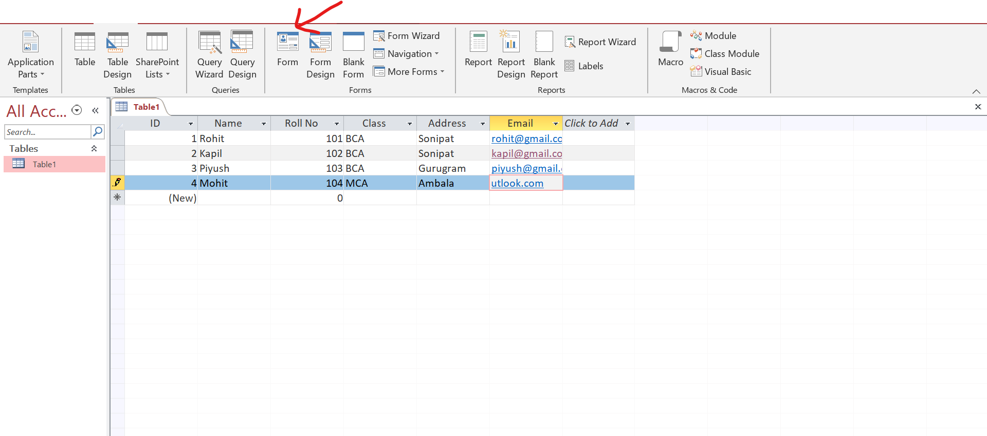

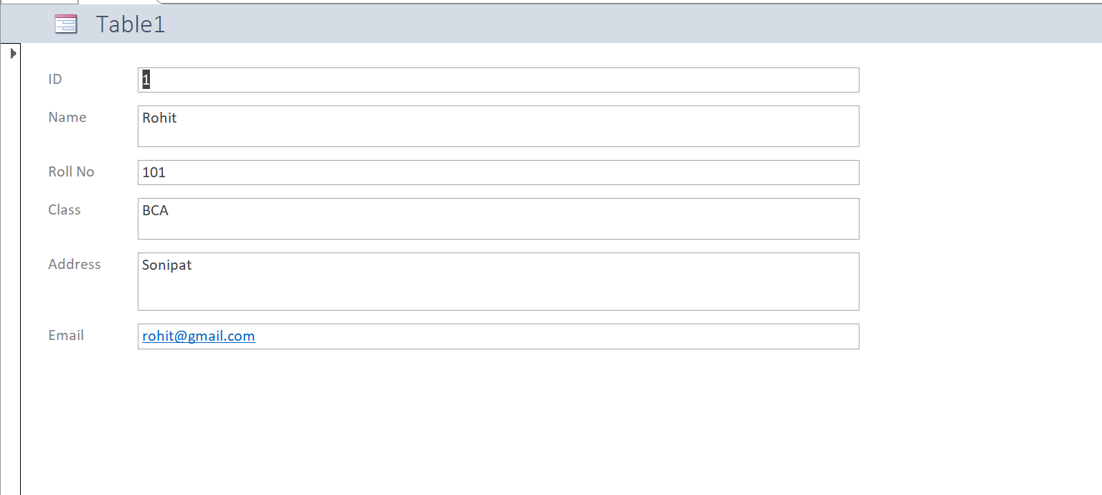

**Add button to add fields to database through form:**

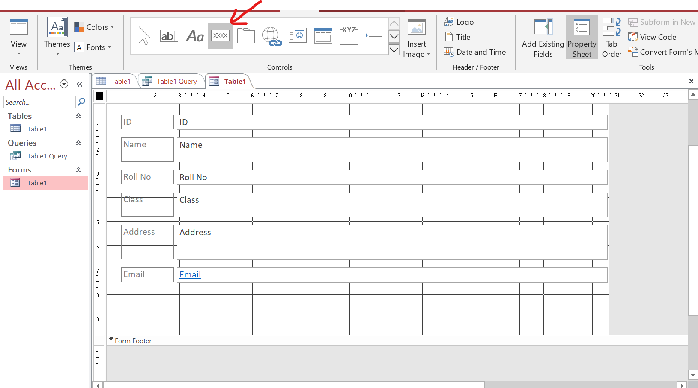

After click a wizard will appear to select the operation of the button which is performed when button is clicked.

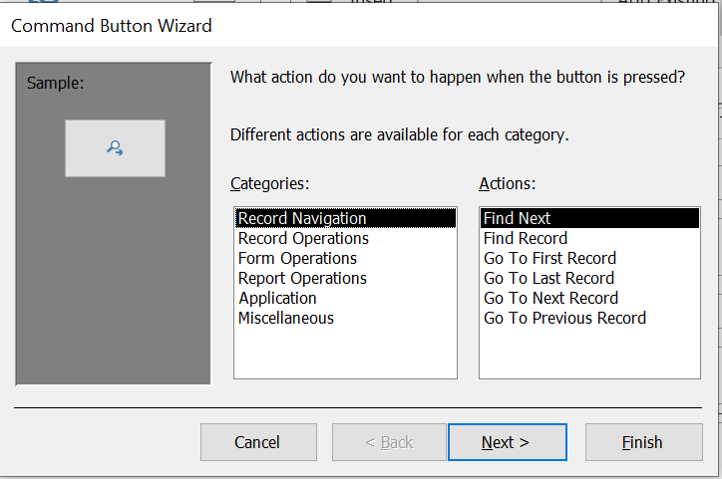

Button to Add a new record (Record Operations->Add a new Record).

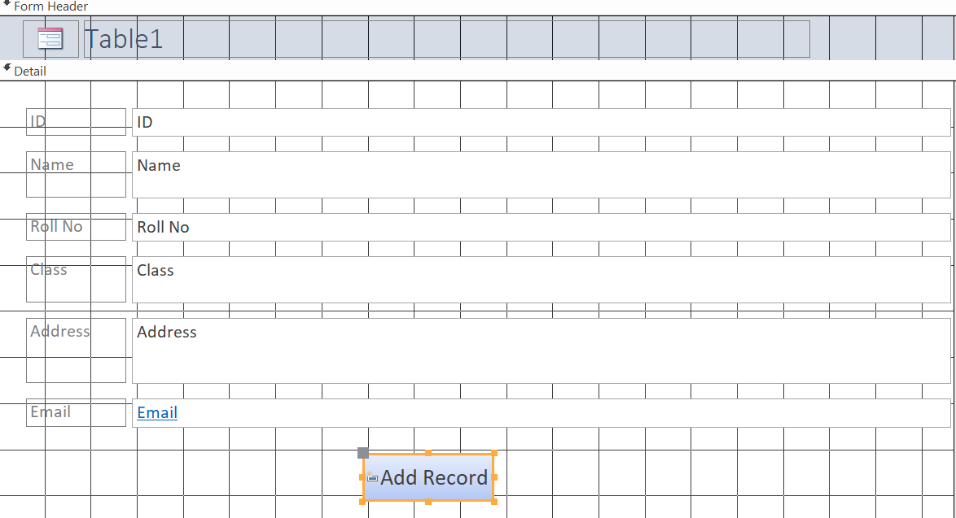

Buttons can perform many operations which are listed in above wizard

Operation like find a record, add record, delete record, save record and close from are performed in below image

**Operations**

Find Record – Record Navigation->Find Record

Delete Record – Record Operations->Delete Record

Save record - Record Operations->Save Record

Close Form – Form Operations->Close Form

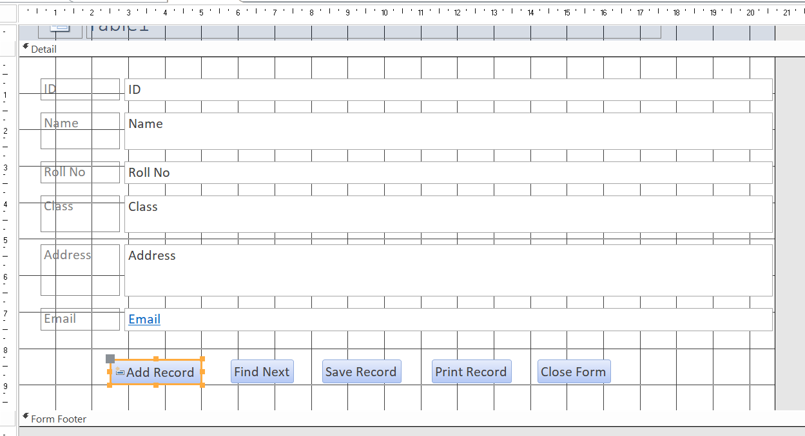

**Creating Queries:**

Select query wizard from create menu.

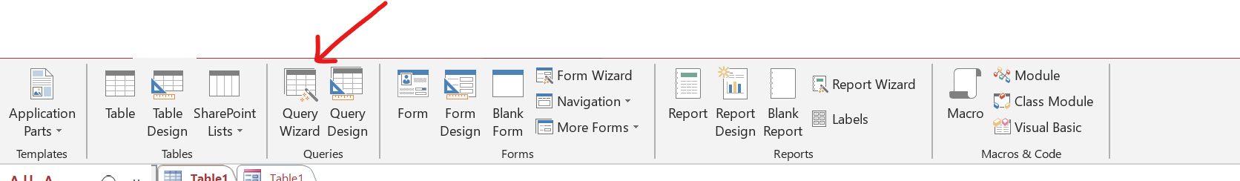

Select type of query to create

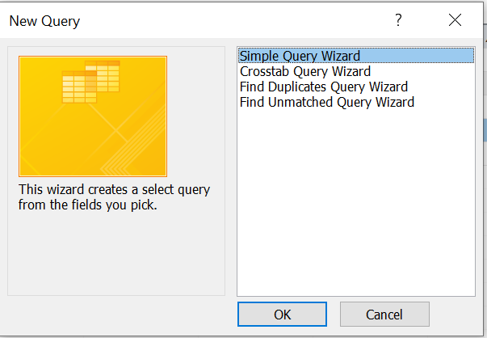

Select fields to be shown when the query will be executed.

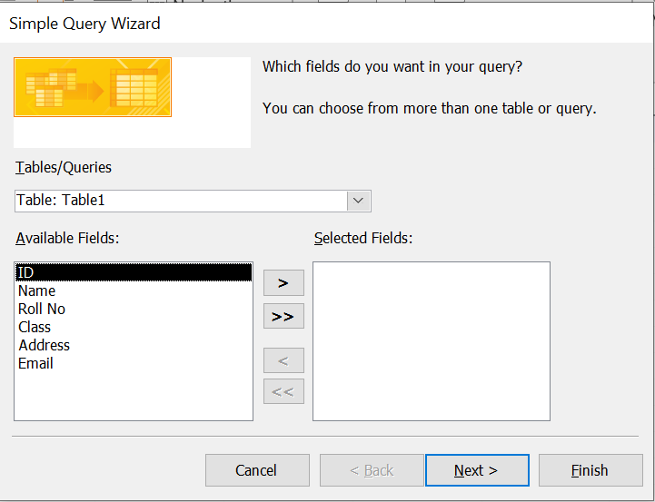

**Design View of a Query:**

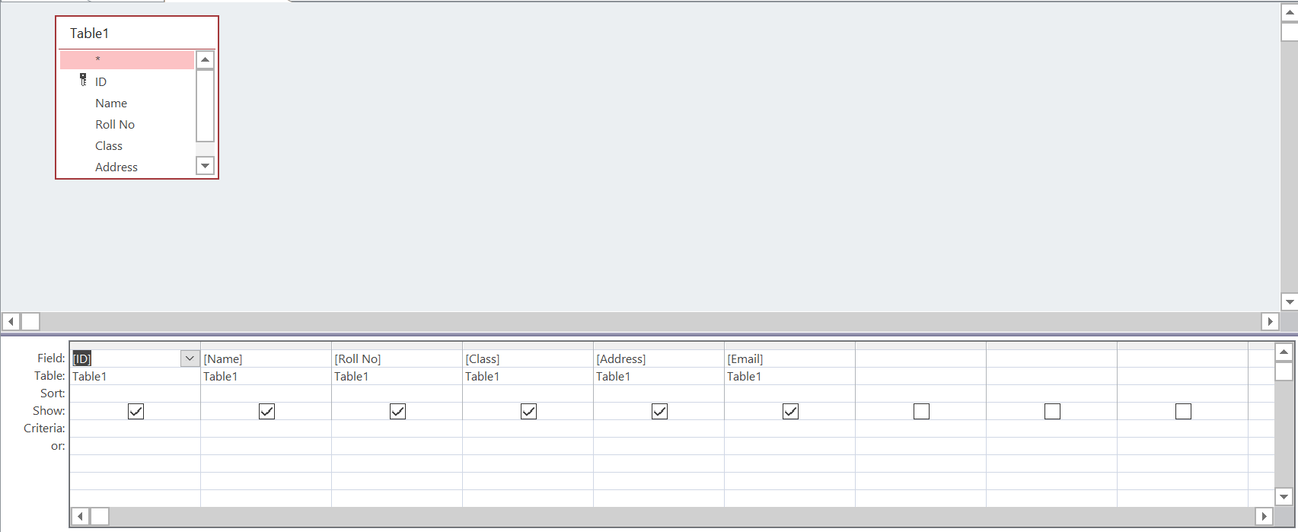

**Criteria of a query:**

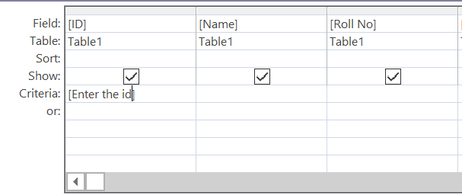

**Execution of a query:**

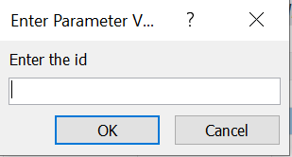

After the value of 4

